Deluge:

sudo apt-get install deluge

A torrent client

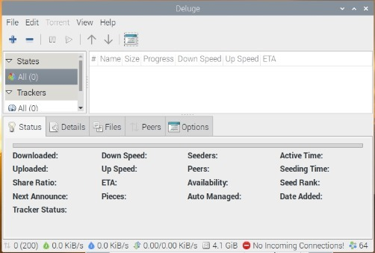

TeamViewer:

Command :

sudo apt update -y && sudo apt upgrade –y

sudo wget https://download.teamviewer.com/download/linux/teamviewer_amd64.deb

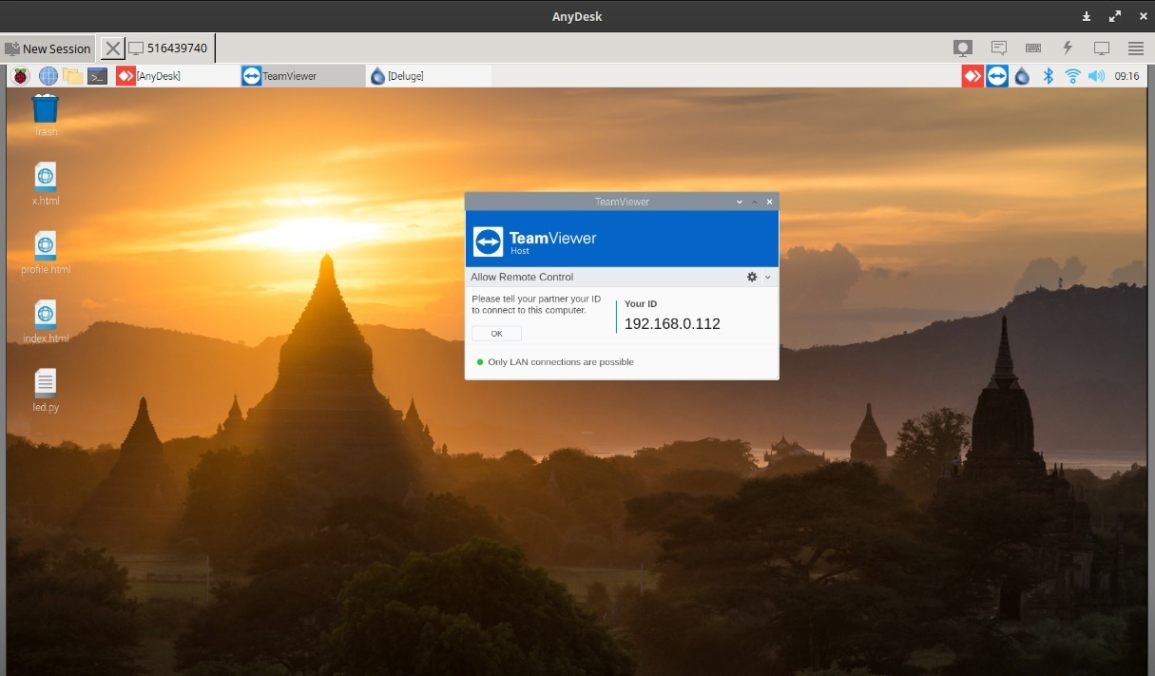

My Paint:

Simple paint alternative

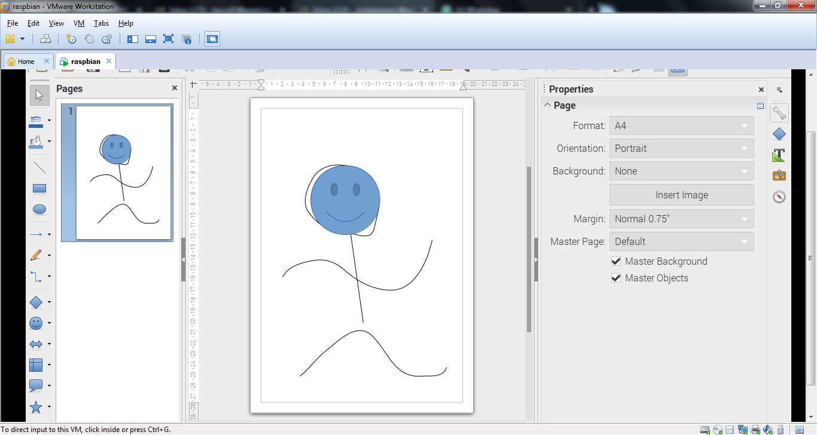

Htop:

A graphical task manager

